Testing a Physical Model

Part of a Series of Activities related to Plasmas and the Solar System

for Middle Schools

**LEAD AUTHORS**

**Vickilyn Barnot**, Assistant Professor of Education,

Director of the Early Child hood Education Program

University of Pittsburgh at Greensburg

Member, Contemporary Physics Education Project

**Katrina Brown**, Associate Professor of Physics,

University of Pittsburgh at Greensburg,

Member, Contemporary Physics Education Project

**Todd Brown**, Assistant Professor of Physics,

University of Pittsburgh at Greensburg,

Member, Contemporary Physics Education Project

**Ted Zaleskiewicz**, Professor Emeritus of Physics,

University of Pittsburgh at Greensburg,

President Emeritus, Contemporary Physics Education Project

**Adapted from an Activity originally authored by**

Robert Reiland, Shady Side Academy, Pittsburgh, PA

Vice-president, Contemporary Physics Education Project

G. Samuel Lightner, Professor Emeritus of Physics, Westminster College, New Wilmington, PA, Vice-president, Contemporary Physics Education Project

Prepared with support from the Department of Energy,

Office of Fusion Energy Sciences,

Contract # DE-AC02-09CH11466

© Copyright 2021 Contemporary Physics Education Project www.CPEPphysics.org

**Preface**

This activity, produced by the Contemporary Physics Education Project (CPEP), is intended for use in middle schools. CPEP is a non-profit organization of teachers, educators, and physicists which develops materials related to the current understanding of the nature of matter and energy, incorporating the major findings of the past three decades. CPEP also sponsors many workshops for teachers. See the homepage [**www.CPEPphysics.org**](http://www.CPEPphysics.org) for more information on CPEP, its projects and the teaching materials available.

**The Student Section of this Activity is structured on the BSCS 5E model for Inquiry instruction.**

The following description of the 5E model is excerpted from the Introduction to the BSCS text:

*BSCS Science: An Inquiry Approach*

***Engage***

***Explore***

***Explain***

***Elaborate***

***Evaluate***

According to the BSCS 5E model, each “E” represents an important part of the sequence through which students progress to develop their understanding. First, students are *engaged* by an event or a question related to a concept, and they have opportunities to express their current understanding. Then they participate in one or more activities to *explore* the concept and share ideas with others before beginning to construct an explanation. Following the initial development of an explanation, students have the opportunity to *elaborate* and deepen their understanding of the concept in a new situation. Finally, students *evaluate* their growing understanding of the concept before encountering a new one. The combination of the 5E model with a strong assessment-oriented design provides opportunities for learning and conceptual change in students, which leads to an improved understanding of science (Bransford, Brown, & Cocking, 2000).

ENGAGE Procedure

1)

Your teacher will organize you into groups of three or four and distribute a large cardboard box to each group.

The box and its contents is the KIT of parts which you will use to construct a model of a real physical process.

2)

Open the large box and inside find a much smaller cardboard box.

**DO NOT open or shake the smaller box.**

3)

Your teacher will prompt you to guess “what might be in the smaller box”?

Your teacher will chart the “guesses” you made and lead a class discussion as to why you made those ”guesses”.

4)

**Now shake the smaller box!**

5)

Now that you have shaken it, your teacher will prompt you to guess what might be in the box.

Your teacher will chart the “guesses” made and lead a class discussion as to why you made those ”guesses”.

6)

**Now open the smaller cardboard box** and find it contains bottle tops that have been taped together to form cylinders. Each of the four large cylinders in the smaller box will have a dot of soft Velcro attached to one end and each of the twelve small cylinders in the smaller box will have a dot of hard Velcro attached to one end. **Confirm that this is true.**

See Figure 1 for bottle top cylinder details.

tape holding bottle tops together

Hooked Velcro vecro cro vvelcrovelcrovelcro

1. A small bottle top cylinder

(b) A large bottle top cylinder

tape holding bottle tops together

Soft Velcro

Figure 1: Bottle top cylinder details

7)

Your next step is to take one small cylinder and one large cylinder and push the Velcro ends together to convince yourself that they will stick together (to form a pair).

8)

Now, place all sixteen cylinders in the smaller box. With the lid closed, shake the box continuously for a few seconds, so the cylinders inside the box move in all directions as shown in Figure 2.

Figure 2: When the box is shaken, the motions of bottle tops will be a variety of speeds and directions.

9)

After shaking the box for a few seconds, open the lid and count the number of pairs of cylinders which stuck together.

10)

Record the number of pairs, N which stuck together here. _____________

(N = the number of cylinder pairs created.)

11)

Now, think of things that you could do which would result in obtaining a larger N when you shake the box. You might want to try some mini-experiments using the parts of your model. In your thinking and/or experimenting be aware that not all collisions of two cylinders will result in sticking (creating a pair). See Figure 3 below.

1. Bottle top nuclei on a collision

path and likely to form a pair

(b) Bottle top nuclei on a collision path with no chance of forming a pair

Figure 3 Bottle tops on pair forming and non pair forming paths*.*

12)

Discuss the possibilities with the members of your group. Your group should be able to suggest several actions that could be taken so that more pairs can be formed ( N can be increased).

Write down here the ways your group thought of in which N could be increased.

a)

b)

c)

d)

e)

13)

Your group should be ready to share your suggestions with the rest of the class.

Your teacher will chart your ideas for increasing N and lead a class discussion

14)

Now, take everything else out of the larger box and arrange the items neatly on your work table:

Bag of 50 large cylinders

Bag of 50 small cylinders

3 bags of 25 small cylinders

A stopwatch

3 pencils and 3 transparent 12 inch rulers

Pad of graph paper

EXPLORE Procedure

1)

The list created in your class of the ways in which N could be increased will probably include the following

a) Shake the box for a longer period of time.

b) Place more bottle top cylinders in the box.

c) Shake the box harder (more vigorously).

d) Replace the Velcro patches with bigger Velcro patches.  
e) Attach Velcro patches to both ends of the cylinders.

These suggestions are related to variables that you could alter in your experiment to affect the number of pairs created (N) when you shake the box.

|  |  |
| --- | --- |
| Possible ways to increase N | Variable that would be changed |
| a) Shake the box for a longer period of time. | Shaking time =      |
| b) Place more bottle top cylinders in the box. | Number of cylinders = n |
| c) Shake the box harder (more vigorously). | Vigor of shaking |
| d) Use larger Velcro patches on the ends | Size of Velcro |
| e) Attach Velcro patches to both ends of the cylinders. | Amount of Velcro |

 is the Greek letter for t - - we are using it to represent the *Shaking time.*

2)

Your first experiment will show how changing the length of shaking time will change the number of cylinder pairs created. Recall that the number of cylinder pairs created is called N. We will call the length of time the box is shaken, . (  = shaking time)

Remember that when performing an experiment only ONE variable at a time should be changed. In this experiment you will be changing . So it is important to keep all the OTHER possible variables [those mentioned in b) thru e) above] constant during this first experiment.

So - - do NOT

Change the number of cylinders in the box

Change the size of the Velcro patches on the cylinders

Change the amount of Velcro patches on the cylinders.

You must also NOT change how hard (vigorously) you shake the box during the entire Activity! Keeping the “Vigor of shaking” constant is very difficult to do. This will be a true test of your experimental skill!

IT IS STRONGLY RECOMMENDED THAT ONLY ONE STUDENT PEFORM THE SHAKING!

3)

It will be important to practice shaking the large cardboard box at a nearly constant rate, time after time, until you can do so reproducibly. Use the stopwatch from your KIT for measuring the shaking time periods ().

**Start with 50 of each type of cylinder in your large box** and gently shake for 10 seconds (10 s). Open the box, and count how many pairs of cylinders have formed. Record this number for Trial 1 in Data Table 1 (next page.)

After separating the cylinders, replace them back into the box. Repeat eight additional trials, shaking the box with the same vigor for 10 s and recording N. Looking at your results in the table will give you a sense of how consistent the vigor of your shaking is. After practicing nine trials, the counts from repeated shakings should be fairly consistent.

Data Table 1

|  |  |
| --- | --- |
| Trial Number | N, number of pairs formed |
| 1 |  |
| 2 |  |
| 3 |  |
| 4 |  |
| 5 |  |
| 6 |  |
| 7 |  |
| 8 |  |
| 9 |  |

4)

Now that you know how to keep the “Vigor of shaking” variable a constant, you are ready to begin your first experiment. In this part you will vary the shaking time, τ, while keeping the number of cylinders (n) constant at 100 and keeping shaking vigor as constant as possible.

You will begin, just as before, by placing the 50 large and 50 small cylinders in the large box, shaking the box for 10s and counting the number of pairs formed. You will record this in Data Table 2 and then repeat this process two more times for 10s each. Next, you will shake the box (with the same vigor) for 20s, 30s, 40s and 50s and complete three trials for each time. Record you data and average values in Data Table 2 below.

**HINT** when shaking for 40s or 50s MANY pairs will be formed - - it might be quicker to count the UN-paired

cylinders and subtract to find the number (N) of pairs that formed.

**Data Table 2**

|  |  |  |  |  |
| --- | --- | --- | --- | --- |
| Time the box was shaken ) | Number of pairs formed first trial | Number of pairs formed second trial | Number of pairs formed third trial | Average number of pairs formed (Navg) |
| 10s |  |  |  |  |
| 20s |  |  |  |  |
| 30s |  |  |  |  |
| 40s |  |  |  |  |
| 50s |  |  |  |  |

5)

Using a sheet of the graph paper and pencils provided in your KIT, label the y-axis Navg and the x-axis τ.

Select a scale for the axis so that all your data points can be plotted on this graph.

Finally, plot the ordered pairs , Navg ) on the coordinate plane you have constructed.

6)

Fit a line to the points and describe any correlation.

Positive? Negative?

EXPLAIN Procedure

Since the title of this Activity is “Testing a Physical Model”, you are probably starting to wonder,

“a physical model of what?” In this (EXPLAIN) section of the Activity, you will find the answer to your question.

1)

Your teacher will give your group a copy of the chart, FUSION: Physics of a Fundamental Energy Source. As you look over the chart, you will see descriptions and graphics of many physical science topics. Some of the topics you will study in high school or possibly in college. Some topics are appropriate for your current grade level. In particular find the block towards the center entitled: TWO IMPORTANT FUSION PROCESSES.

The process on the right in the block: “p-p” SOLAR FUSION CHAIN (Figure 4)

is the rather complicated process which generates the majority of energy given off by our Sun. You may study this process during high school or if you should go on to college.

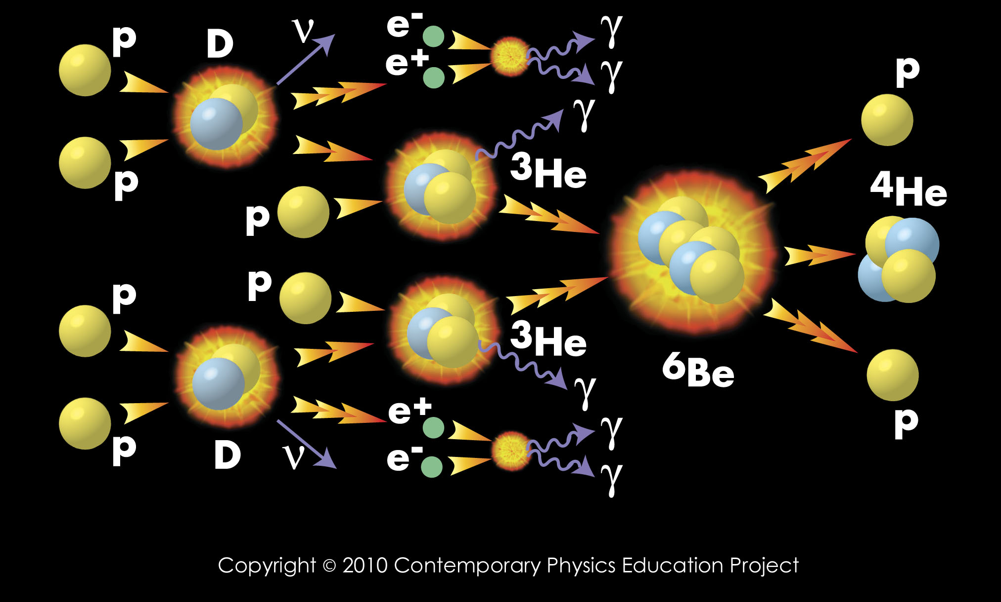

Figure 4 The “p-p” solar fusion chain

The process on the left in the block: D + T = 4He + 1n (Figure 5)

is the process you are modeling in this Activity. It is much simpler than the “p-p” fusion chain and is the reaction that will most likely be used in the first fusion reactors to generate electricity on a commercial basis.

This reaction is sometimes referred to as simply the “D + T” reaction.

**Reactants Fusion Products**

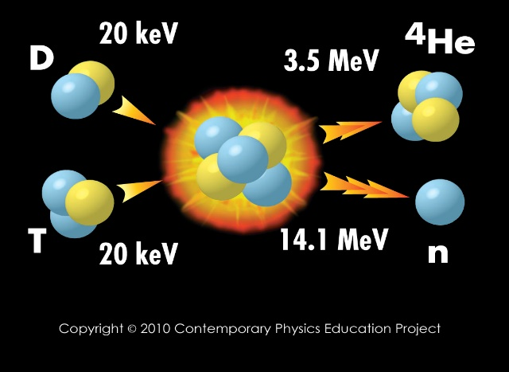

Figure 5 : The “D+T” Reaction

Fusion occurs when low mass nuclei combine to make more massive nuclei (as simulated in this activity).

2)

What do the symbols D and T represent?

D and T represent two different types of hydrogen. Remember that hydrogen is the simplest type of atom and that a hydrogen atom will ALWAYS have only one proton. The most common type of hydrogen atom has a proton (p) for its nucleus and no neutrons. This type of hydrogen is sometimes written as 1H. The ‘1’ tells us that there is one thing in the nucleus, a single proton.

Another type of hydrogen can have one proton as well as one neutron in the nucleus. This is called a deuteron, D, and it is sometimes written as 2H. The ‘2’ tells us that there are two things in the nucleus (one proton and one neutron). It is still a type of hydrogen since it contains only one proton. Look at the D+T graphic on your chart and locate a D.

And another type of hydrogen can have one proton as well as two neutrons in the nucleus. This type of hydrogen is called a triton, T, and it is sometimes written 3H. The ‘3’ tells us that there are three things in the nucleus (one proton and two neutrons). Since there is only one proton, we know that this is still a type of hydrogen. Look at the D+T graphic on your chart and locate a T.

The D and T each have one proton, but they have different numbers of neutrons: D has one and T has two. When nuclei contain the same number of protons, but different numbers of neutrons they are called *Isotopes*. The number of protons determines the type of atom, and since both the D and T have one proton they are both types of hydrogen.

Figure 6 may help you visualize the three isotopes of hydrogen.

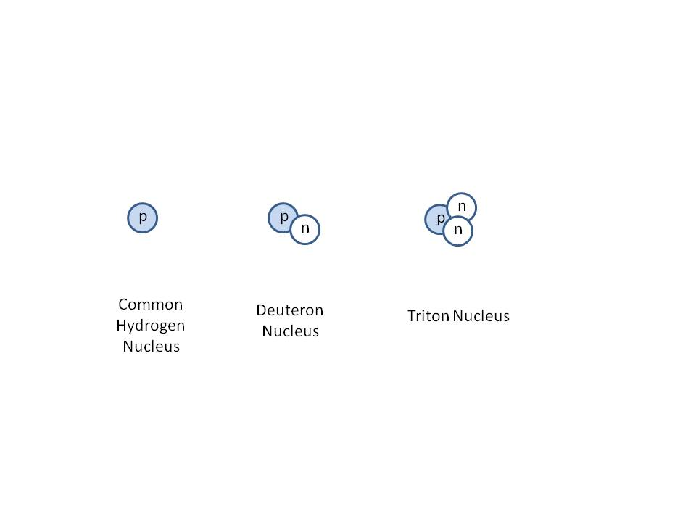

Figure 6: The three varieties (isotopes) of a hydrogen nucleus

What does the symbol 4He represent?

He stands for helium and this is another type of atom. EVERY helium atom will have two protons. 4He is a helium nucleus and the ‘4’ tells us that it contains four things inside of the nucleus. Since we know that helium must have two protons, then 4He must have two protons and two neutrons in the nucleus. It is sometimes called an alpha particle, . Look at the D+T graphic on your chart and locate an  (4He).

What does the symbol 1n represent?

‘1n’ stands for a neutron. The ‘1’ tells us that there is one thing in the nucleus: a neutron. So 1n represents a single neutron. Look at the D+T graphic on your chart and locate a 1n.

3)

Using the pictures from the chart, Figure 6, and the definitions above, fill out the following table:

|  |  |  |  |
| --- | --- | --- | --- |
| Symbol | Number of protons | Number of neutrons | Is this a type of hydrogen? |
| D |  |  |  |
| T |  |  |  |
| 2H |  |  |  |
| 3H |  |  |  |
| 4He |  |  |  |
|  |  |  |  |
| 1n |  |  |  |
| 1H |  |  |  |

4)

When you look at the D+T graphic you can see that a D and a T combine to create a large nucleus. That large nucleus is not stable so it then breaks apart into a 4He and an n. In this Activity, “Testing a Physical Model”, the small bottle top cylinders play the role of the Ds and the large bottle top cylinders play the role of the Ts. The combined pairs of bottle top cylinders represent the final alpha particles (4He) produced. The model does not have a component that corresponds to the neutrons or the large unstable nucleus.

Finally, the graphic for the real D + T reaction (Figure 5) shows that the  carries off 3.5 MeV of energy and the n carries off 14.1 MeV of energy, for a total energy of 17.6 MeV. The combined pair of cylinders in this model do not really carry off any energy but the objects that they represent would.

Optional (Extra Credit) calculation

@@@@@@@@@@@@@@@@@@@@@@

Begin Optional calculation

5)

Where does this energy come from in the real D + T reaction?

The energy arises from the conversion of mass to energy according to the equation,

E = mc2.

Where: m = mass of (D + T) – mass of   + 1n)

c = the speed of light

E = energy released

6)

Your group can actually calculate the energy released in the real D + T reaction using information on the chart. Look in the lower left hand corner of the chart and locate the list called “Useful Nuclear Masses”.

7)

Find the appropriate masses from the list and fill in the table below.

|  |  |  |  |
| --- | --- | --- | --- |
| Mass of D | Mass of T | Mass of  | Mass of 1n |
|  |  |  |  |

Use these masses to find the Mass (D + T) and the Mass ( + 1n) and write the values below and in the following table. For instance, to find the Mass (D + T) you will take the Mass of D and add it to the Mass of T.

Mass (D+T) =

Mass ( +1n) =

m = mass of (D + T) – mass of  + 1n) =

|  |  |  |
| --- | --- | --- |
| Mass (D + T) | Mass ( +1n) | m = mass of (D + T) – mass of  + 1n) |
|  |  |  |

8)

Use the m you calculated and the formula below to find the energy released.

E = m x 931.466MeV/c2.

9)

How well does your value for E compare to the information given in the D + T graphic?

(Recall the graphic for the real D + T reaction (Figure 5) shows that the  carries off 3.5 MeV of energy and the n carries off 14.1 MeV of energy, for a total energy of 17.6 MeV)

10)

17.6MeV is really not a lot of energy. So, how BIG is the amount of energy given off with EACH fusion?

It would actually take ten million, million fusions per second to power a 30 watt fluorescent bulb.

End Optional calculation

@@@@@@@@@@@@@@@@@@@@@@

ELABORATE Procedure

1)

Recall the class list of ways to increase the number of pairs formed (N) - - which we will now call the number of fusions which occurred - - contained the following items:

1. Shake the box for a longer period of time.
2. Place more bottle top cylinders in the box.
3. Shake the box harder (more vigorously).
4. Replace the Velcro patches with bigger Velcro patches.
5. Attach Velcro patches to both ends of the cylinders.

In the EXPLORE part of this Activity your group investigated how N depended on    (shaking time - shaking the box for a longer period of time) holding all the other variables constant.

2)

In the ELABORATE part you will investigate how N depends on “place more bottle top cylinders in the box”, while holding all the other variables constant. The number of bottle top cylinders in the box will be called n.

(n =TOTAL number of cylinders)

3)

Your group’s task in this ELABORATE part is to decide on a series of measurements by which you will investigate how N (number of pairs formed) varies with n (TOTAL number of large and small cylinders in the box). You will want to vary n while holding the other variables constant:

1. Shaking time should not change.

c) Shaking vigor should not change.

d) The size of the Velcro patches should not change.

e) The number of Velcro patches should not change.

NOTE: n is sometimes called the particle concentration.

n is the TOTAL of both types of bottle top cylinders (small + large)

4)

HINTS to help your group plan what to measure, how to measure it, etc.

HINT A

If you select one of the times used in the EXPLORE Data Table 2 as the time ) for each measurement in this section, then you can use the results for that time (from Data Table 2) in this experiment. It would correspond to the data point where n would be 100. (50 large plus 50 small cylinders)

HINT B

To vary particle concentration, n, increase or decrease the number of ONE of the types of cylinders. Since you have only 50 of the large cylinders - - and 125 of the small cylinders - - vary n by changing the number of small cylinders in the box. Keep the time the same, shaking in the way that you found easiest to reproduce in the previous trials. Do this at least three times for each concentration and find an average.

HINT C

Plan to make a graph of (Navg) vs. n.

5)

The time for each shake of the box is _____________s. Be sure to take enough data to complete Data Table 3:

Data Table 3

|  |  |  |  |  |
| --- | --- | --- | --- | --- |
| TOTAL number of cylinders in box (n) | Number of pairs formed first trial | Number of pairs formed second trial | Number of pairs formed third trial | Average number of pairs formed (Navg) |
| 75 |  |  |  |  |
| 100 |  |  |  |  |
|  |  |  |  |  |
|  |  |  |  |  |
|  |  |  |  |  |

6)

Using the graph paper and pencils from your KIT, label the y-axis Navg and the x-axis n.

Select a scale for the axis so that all your data points can be plotted on this graph.

Finally, plot the ordered pairs n, Navg) on the coordinate plane you have constructed.

7)

Fit a line to the points and describe any correlation.

Positive? Negative?

EVALUATE Procedure

1)

In this final part of the Activity, you and your group will discover how fusion is accomplished in the real world and how well your model compares to the real world situation.

2)

An important graph.

Look toward the lower right hand corner of the chart, FUSION: Physics of a Fundamental Energy Source, and locate the box entitled: ACHIEVING FUSION CONDITIONS. In particular, focus your attention on the graph, Confinement Quality (n) vs. Ion Temperature.

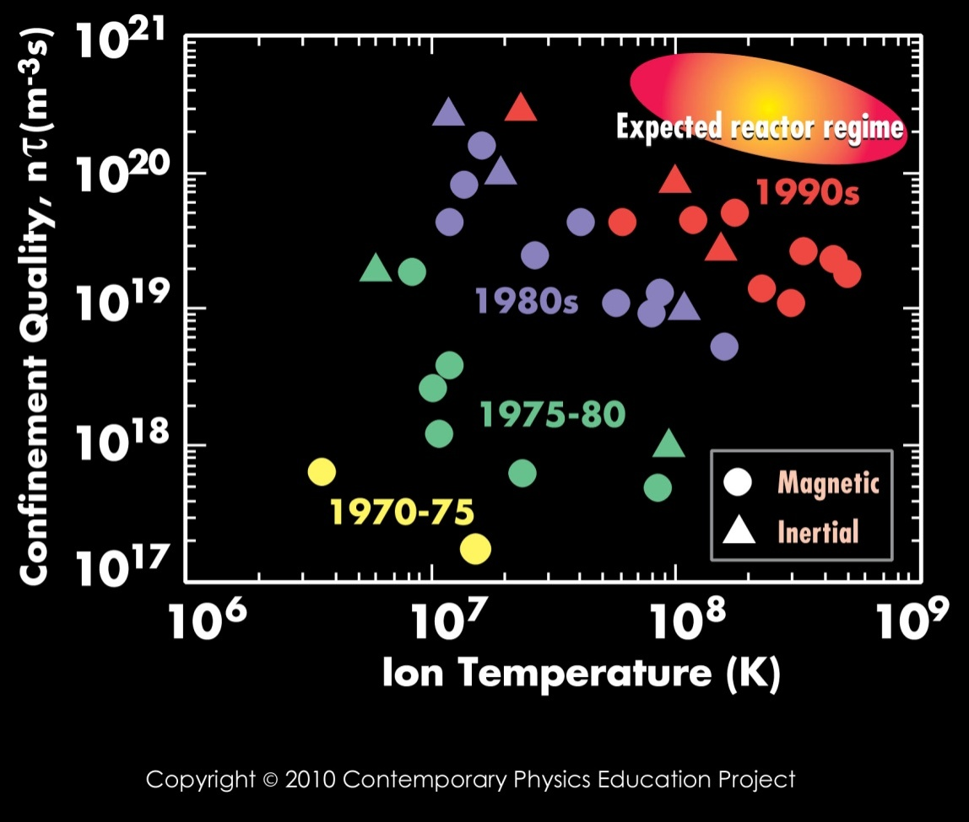

Figure 7: Graph of Confinement Quality vs. Ion Temperature

Ion Temperature is the temperature of the particles undergoing fusion. The particles are called ions because they are atoms which have been broken down into their positive nuclei and negative electrons. In other words, the electrons are no longer attached to the nuclei. The special name given to a mixture (gas) of ions is a *plasma*.

Confinement Quality is a measure of how well a plasma can achieve fusion. Note that n and  mean the same things in the real world as they do in your model: n is the number of particles and  is the time in which the reaction occurs.

In the real world, fusion takes place when a plasma is confined in a reactor (sometimes called a reactor vessel).

In your model of fusion, your bottle top cylinders (ions) are confined to the box you are shaking.

3)

Are the bottle cap cylinders in your model charged plus or minus - - or not charged at all?

What about the objects that they represent?

4)

More information related to Figure 7

The triangle points in Figure 7 represent the conditions which have been obtained in real world reactors using “inertial” techniques to confine the plasma sometimes called “Laser-beam-driven Fusion”

The circle points in Figure 7 represent the conditions which have been obtained in real world reactors using

“magnetic” techniques to confine the plasma.

Inertial and Magnetic Confinement are simply two ways to confine a fusion reaction. Your teacher may provide you with more information about these two techniques if he/she feels it is appropriate

5)

How are the bottle top cylinders (ions) confined in your model?

In the upper right hand corner of the graph in Figure 7 is an orange “balloon” labeled “Expected reactor regime”. Points (representing reactors) must lie within this balloon to be considered a “successful” reactor. Note that this is the region of the graph that represents high values of n and high values of Ion temperature.

6)

Are any current reactors (triangles or circles on the graph) “successful” - - do any of the circles or triangles lie within the “balloon” labeled “Expected reactor regime”?

The graph in Figure 7 shows that the larger the value for the product of n (n times ) the more likely it is to have a successful fusion reactor. Since this is a mathematical product, increasing EITHER n or  should increase the chance of a successful reactor (more fusions - - Navg- - produced).

7)

Does the data you have taken (and graphed) in the Explore and Elaborate sections of this Activity show

Navg increased as  was increased?

Navg increased as n was increased?

The graph in Figure 7 shows that the larger value for the Ion Temperature the more likely it is to have a successful fusion reactor (larger value for - Navg).

8)

Of the variables associated with your model of fusion

1. Shaking time
2. Number of cylinders in box
3. Shaking vigor
4. Size of Velcro
5. Number of Velcro patches

which one does your group think would correspond to Ion Temperature?

9)

List the ways in which your model represents a real fusion reactor well.

10)

List the ways in which your model represents a real fusion reactor poorly.

Glossary of terms:

α (alpha) particle: a helium nucleus that contains two protons and two neutrons.

Atomic mass: The sum total of protons and neutrons in the nucleus of an atom. This is denoted by the symbol A

Atomic Mass Unit: the standard unit of mass when on the scale of an atom or nucleus. The symbol for this is u.

Ionized: the state of an atom which has an imbalanced of net charge from either losing or gaining electrons.

MeV: Abbreviation for Mega election volt: a unit of energy that used to described nuclear reactions.

Nucleons: parts of a nucleus that can be either protons or neutrons

Proton: Positive charged massive particle often found in a nucleus.

Neutron: uncharged massive particle often found in a nucleus.

Electron; relatively light negatively charged particle often found “in orbit” around a nucleus

Ion: an originally electrically neutral atom that has lost or gained electrons.

Isotopes: nuclei having the same number of protons but different number of neutrons.

Deuteron (D) : isotope of hydrogen containing one proton and one neutron.

Triton (T): isotope of hydrogen containing one proton and two neutrons.

Ion Temperature: a measure of the energy of ions in a plasma.

n: particle concentration or number of cylinders in the shake it box.

1n: a neutron - - neutral massive particle often found in a nucleus

N: number of pairs formed after a shake it experiment.

Magnetic confinement fusion: is an approach to generating [fusion power](http://en.wikipedia.org/wiki/Fusion_power) that uses [magnetic fields](http://en.wikipedia.org/wiki/Magnetic_field) to confine the hot fusion fuel in the form of a [plasma](http://en.wikipedia.org/wiki/Plasma_(physics)).

Inertial confinement fusion (ICF): is a process where [nuclear fusion](http://en.wikipedia.org/wiki/Nuclear_fusion) reactions are initiated by heating and compressing a fuel target, typically in the form of a pellet that most often contains a mixture of [deuterium](http://en.wikipedia.org/wiki/Deuterium) and [tritium](http://en.wikipedia.org/wiki/Tritium).

Confinement Quality (nτ): is a measure of how well a plasma can achieve fusion. Note that n and  mean the same things in the real world as they do in the model: n is the number of particles and  is the time in which the reaction occurs.

τ: is the symbol used to denote shaking time.

Plasma: the Fourth State of matter.

Tokamak: torus shaped device used to confine the plasma in magnetic confinement fusion devices.

E = mc2 : One of the most important equations in physics. Einstein’s theory of relativity equation relating mass to energy.

D+T reaction: is the process modeled in this Activity. It is the reaction that will most likely be used in the first fusion reactors to generate electricity on a commercial basis.

“p+p”( SOLAR FUSION CHAIN): is the rather complicated process which generates the majority of energy given off by our Sun.